California State University Fullerton

CPSC 462



Object Oriented Software Design

Domain Model

for the

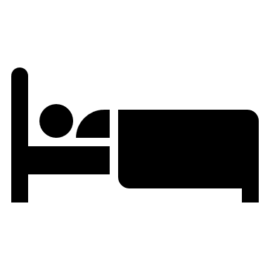

Hotel Room Reservation System

|  |
| --- |
| **Allen Rivas** |
| Chief Technical Officer |
| [allen.rrivas@csu.fullerton.edu](mailto:allen.rrivas@csu.fullerton.edu) |

Revision History:

| Version | Date | Summary of Changes | Author |
| --- | --- | --- | --- |
| 1.1 | April 27, 2021 | * Initial Release. Provided Domain’s Major Concepts with the domain model of all components. | Allen Rivas |
| 1.2 | May 16, 2021 | * No changes made. | Allen Rivas |

Table of Contents

1 Domain’s Major Concepts 1

1.1 Hotel 1

1.2 Payment Type 1

1.3 Amenities 1

1.4 Room 1

1.5 Reservation 1

1.6 Floor 1

1.7 Room Type 1

1.8 Profile 1

1.9 Membership 1

1.10 Bill 1

1.11 Date 1

2 Domain Model Diagram 2

# Domain’s Major Concepts

## Hotel

Hotel accepts many payment types. A hotel supplies many amenities. A hotel rents many rooms. A hotel issues many reservations.

## Payment Type

Many payment types are accepted by many hotels. A payment type appears on many bills.

## Amenities

Many amenities are supplied for many hotels.

## Room

Many rooms are rent in a hotel. From 1 to 25 rooms reside on one floor. One to many rooms are reserved by many reservations. Many rooms describe 1 to many room types. A room is listed on a bill.

## Reservation

Many reservations are issued in one hotel. Many reservations reserve 1 to many rooms. Many reservations apply zero to one membership.

## Floor

One floor resides 1 to 25 rooms. One floor specifies one profile.

## Room Type

One to many room types describes zero to many rooms. Zero to many room types specifies zero to many profiles. Zero to many room types appears on zero to one bill.

## Profile

One profile is specified on one floor. Zero to many profiles are specified on zero to many room types. One profile is contained on one membership.

## Membership

One membership contains one profile. Zero to one membership applied on zero to many reservations. One membership is displayed on zero to many bills.

## Bill

Zero to many bills appeared on one payment type. A bill lists a room. Zero to one bill appears on zero to many room types. Zero to many bills displays one membership. Zero to many bills lists 2 dates.

## Date

2 dates list on zero to many bills.

# Domain Model Diagram

